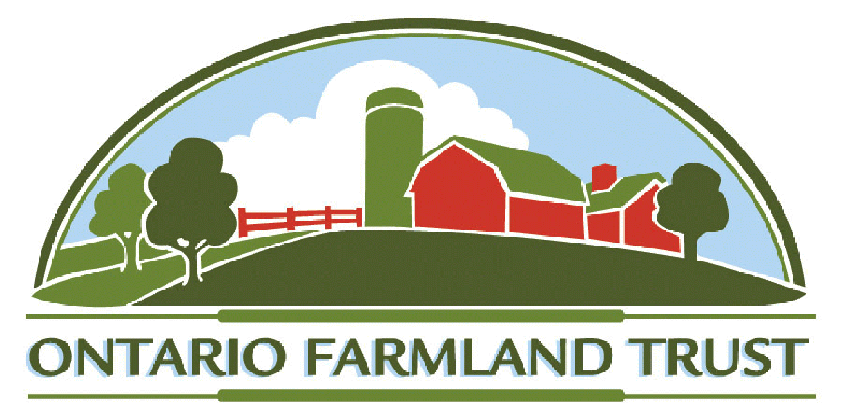

Board Organization and Committee Responsibilities

Recommended by: | Governance Committee | Date issued: | Feb 19 2015
Effective date: | Immediate | Revised: | Feb 04 2015
Replaces: | Jan 16 2013 | Approved by the Executive | Feb 04 2015
Next Review Date: | January 2017 | Approved by the Board | Feb 18 2015

Background on Governance:
In full accord with its constitutional bylaws, the OFT Board of Directors, comprised of up to 15 members, governs the business and property of the Trust. The bylaws prescribe operating rules for Trust membership, powers and duties of the Board, Officers, Staff, Committees and requirements for financial reporting, auditing, record keeping and meetings. The Chair, Vice Chair, Secretary and Treasurer are Officers of the Trust.

The Executive Committee includes the four Trust Officers and the Chairs of the Program Committees (aka Standing Committees). The Chair and Executive Committee guide the business operations of the OFT, supervise the Executive Director, coordinate activities of all Trust Committees and oversee implementation of the approved Trust annual budget and work priorities by exercising its delegated powers as authorized by the Board.

Framework for Committees:
The Board of Directors will establish Program Committees, Subcommittees and Task Groups as may be needed to help carry out the implementation of its approved objects, vision, mission, strategic plan, goals, priorities, programs and annual budgets.

The Board will also approve the terms of reference, membership, chairpersons and general guidelines for routine expectations and operation of Committees. The Board will annually appoint the Committees and their Chairs immediately following each AGM and may modify its Committees and memberships at any time.

All of the Program Committees are strongly encouraged to include both interested Board members and other volunteer expertise. OFT Committees are responsible in consultation with staff for developing programs, policies, priorities and projects and recommending timely actions for Board approval in their program areas.
Currently under the OFT bylaws, the Board has continued or established and renewed or revitalized the following OFT Framework for its Committees:

- Executive Committee - incl. Governance Subcommittee or Task Groups dealing with bylaws, governance policy, audit, budget, finance, human resources, Board orientation/training and Board nominations process
- Fundraising Committee
- Education and Policy Committee
- Land Securement and Stewardship Committee

The Executive Committee consists of the Trust Officers and the Chairs of the regular Program or Standing Committees and may include the Chair of a year round Governance Subcommittee or other officers such as the Past Chair (ex officio member and subject to availability of Past Chair) at the discretion of the Board from year to year.

Guidelines for Committees and Chairs:
- The Board of Directors will establish Program Committees and Task Groups as appropriate to help the OFT carry out its objects, vision, mission and programs by appointing Committees and Chairs following each AGM and may modify these Committees and memberships to satisfy OFT needs and fill vacancies.
- Program Committees are strongly encouraged to include both interested Board members and other volunteer experts who are willing to contribute their talents and time to developing policies or programs and engaging in work of the Trust.
- All Regular Committees, Subcommittees and Task Groups must have Terms of Reference that are approved by the Board and periodically reviewed.
- All Committee members will receive terms of reference, briefing notes, policy documents, support from designated staff, orientation sessions and agenda materials to assist them in carrying out assigned Committee activities.
- Committees are responsible in consultation with the ED and assigned staff or consultants for reviewing policies, priorities and projects, estimating annual work plans, resources and budget needs, evaluating goals and program results and recommending decisions for Board approval in their program areas.
- Chairs of Committees are members of the OFT Executive Committee and make routine oral and written reports on Committee activities to the Board.
- Committees will establish suitable meeting dates, organized agendas and timely work plans to pursue the OFT Strategic Plans, Programs and Priorities.
- Committee Chairs (with designated staff support) will send out agendas with reports for decision items about one week before regular meetings. A general protocol to facilitate the orderly conduct of meetings is attached as Appendix 1.
- Committees must keep brief and accurate records or minutes of their meetings that include notes on their discussions and motions on their decisions.
- Minutes or records of Committee meetings will be distributed in the following week to assist in tracking actions and then approved at the next meeting.
- Committee Chairs will consult with the ED and receive advice.
- Committees may take on other tasks as assigned.

Appendix 1 - Protocol for Conduct of Meetings

A general protocol has been useful in the conduct of efficient and effective meetings. Although these simple guidelines do not fit all circumstances, Chairs of Committees and Staff are strongly encouraged to follow these procedures in their meetings. In formal sessions, Roberts Rules of Order can also guide the decision-making. When an informal dialogue is beneficial, the Chair and the Committee can relax the rules. Without routine discipline, Committee meetings will be too long and agendas may not be finished.

- Approval of agenda and minutes
  - Add, confirm or change agenda items
  - Ensure all reports have been received
  - Approve minutes of previous meeting

- Declaration of conflicts of interest
  - Specify the conflict and keep a record

- Speakers to address the Chair
  - Members to signal their desire to speak to the Chair
  - Staff to do same if they wish to speak or add clarity
  - Chair will list and recognize the members in order
  - Please do not talk at random as this is disruptive
  - Committee meeting should stick to the agenda
  - Chair may relax protocol to prompt discussion

- Chair to coordinate the agenda
  - Staff or member presents their report on item
  - Committee asks questions to understand issues
  - Chair calls for a decision or a motion on direction
  - Further clarification & discussion on item if needed
  - Secretary confirms content for a motion or decision
- Chair notes consensus and/or calls for vote on motion

- Committee should stay on topic
  - Add or request information and suggest actions etc.
  - Try to avoid any unrelated, off the topic discussion

- New, other and future business
- Circulate the reports in advance for all decision items
  - Otherwise defer item for a report at next meeting

Reminder: Chairs and Committees must ensure minutes are made as a record of their meetings, discussions, reports and decisions. These can be brief summaries of agenda items discussed with motions or consensus on the outcomes. Minutes are copied to the Trust office and may be tabled as or with Committee reports at Board meetings. Policy and property recommendations are attached to reports coming to the Board.

